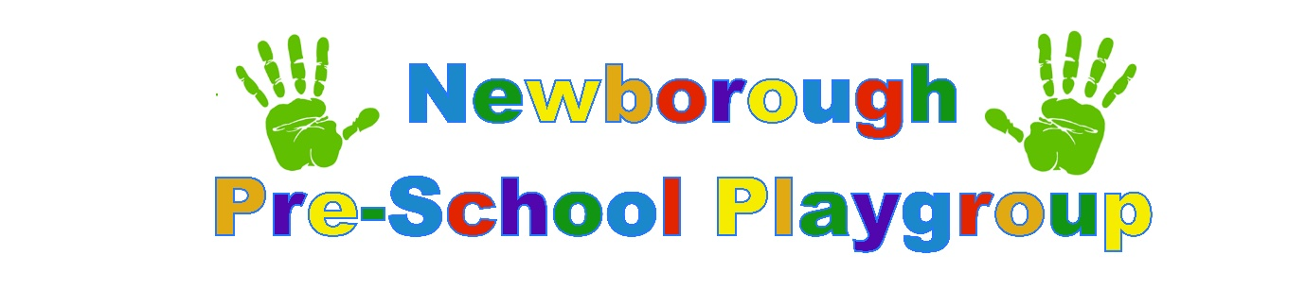
All about me!
Help us to get to know your child before they start at our setting. The more information you can provide us with the more we can plan and work towards your child starting at our setting.
This document is to be completed by parent/ carer prior to your child starting pre-school. The information you provide us with will help to give us an indication as to their starting point. Once your child has started pre-school your child’s key worker will also do an initial assessment and this is where we will begin your child’s journey of development in pre-school.

Date: | Child’s Name: | DOB:

Personal, Social & Emotional Development. | Parents Comments:
Does your child like to be with familiar people and how do they react when they meet someone new?
Has your child started to play with other children? If yes how did it go?
Please tell us if your child already has friends who already attend the setting!

Does your child take pleasure in being able to achieve tasks without adult support?
Does your child show a preference to what he/she likes?
If so, how are they likely to show this?

Can your child ask for help from adults? If so how?

How does your child seek comfort i.e. adult, cuddle, teddy?
Has your child started to understand boundaries? How?
We like to work together with families please tell us if you use time out or something similar within the home!
Please tell us if your child attends groups or activities such as swimming or karate.

Any hobbies/interests?

Communication & Language | Parents comments:
Does your child enjoy listening to music/rhymes? How does he/she react?
Please tell us their favourites!
Does your child enjoy listening to stories?
Please tell us their favourites!
Do they sit for long or just a short time?

Has your child started to understand some language i.e. Where’s your nose? Where’s mummy?
Can your child understand simple instructions i.e. throw the ball?
Can your child understand more complex sentences i.e. put the book away and get a drink?
What is the main language spoken at home?
Does your child speak/understand any additional languages?
How does your child communicate?
Babble, cry, one word?
Asking questions
Hold a conversation?

Do you have any concerns regarding your child’s speech and language?
If so please let us know.
Has your child attended any speech and language appointments?
Are they still ongoing?

Physical Development | Parent Comments:
Has your child had a 2-year check completed by their health visitor?
Does your child have any ongoing/long term health issues?
Do you have any concerns regarding your child’s general health and well-being?
Does your child have any known allergies to food/ medication/ sun cream etc?
Please tell us about your child’s eating habits!
Do they have favourite foods?
What do they dislike?
Does your child use a lipped cup or a normal cup for drinking?
Do you have any concerns regarding your physical abilities?
Is your child toilet trained?
If not are you happy for us to encourage this?

Do they wear a nappy/ pull up pants or proper pants?
If they are toilet trained are, they independent or need assistance to go and with wiping etc?
How will they normally indicate they need the toilet?
Is your child able to dress/undress themselves, independently or do they need a little adult help?
Can they put their shoes and coats on independently?

