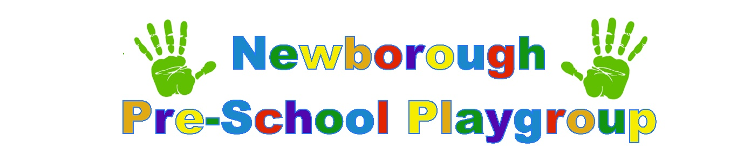
Child personal details/information document.
Child’s full name
Child’s preferred name
Family religion/culture
(If applicable)

Ethnicity
Gender
Child’s date of birth

Child’s/ family home address
Details of any siblings/
Step siblings

Home telephone number

Main carers work number/s

Main carers mobile number/s
Main carers email address/s

Who has parental responsibility for the child? | If you are unsure information can be gained from Gov.Uk or we have a printed copy for you to view.
Please provide name and contact details of 2nd person/persons to contact in case of emergency or illness.

Name of person/persons who would normally collect the child.

Please provide a password to be used in cases where an authorised person is unable to collect your child.
Name, address and contact details of family doctor and health visitor

Has your child had a 2 year health check
What is the main/1st language spoken within the home

Do you require support with literacy/verbal information if English is not the 1st language of the family
Does the child have any known allergies to food/medication/sun cream etc.
Does your child have any special dietary requirements/restrictions?

Does your child have a favourite food they like to eat for snacks (healthy choices)?

Does your child have any long term/ ongoing health issues we need to know about?
Has your child received all their immunisations? | Please see separate sheet.
Does your child require a health care plan?
Does your child have any special needs or disabilities?
Are any of the following in place for your child?
SEN action plan
Education, health & Care Plan?
Are any of the following agencies involved with your child?
Social care worker
Speech & Language
Any others please state.
Do you have any general concerns regarding your child’s health and wellbeing?

Do you have any concerns regarding your child’s speech and language?

Do you have any concerns regarding your child’s physical abilities?

Is your child toilet trained?
If not are you happy for us to encourage this?

Do they need assistance to wipe themselves?
Do they wear nappies/pull ups or proper pants?
How does your child normally indicate they need the toilet?
How does your child sleep?
Would they usually nap during the day?
Does your child drink from a lipped/normal cup
Is your child able to dress/undress themselves?

Is your child able to put their own shoes and coat on?
Please tell us a little bit about your child’s hobbies/interests

Do they have any favourite song/stories?

Does your child have any additional interests’ swimming/karate etc?
Does your child attend another setting? (if so please provide us with contact details and name of key person)

Preferred school at time of transfer?

Please provide any other additional information you think we may need to know.
The information I/we have provided is correct to the best of my/our knowledge and I/we understand it is our duty to provide changes in circumstances / phone numbers etc. | Parents/carers please sign and date
Information sharing!  Please sign to acknowledge your understanding and to give your consent. | We record and share information about children and their families (data subjects) in line with the six principles of the General Data Protection Regulations (GDPR) (2018) which are further explained in our Privacy Notice that is given to parents at the point of registration The six principles state that personal data must be:  - Processed fairly, lawfully and in a transparent manner in relation to the data subject.  - Collected for specified, explicit and legitimate purposes and not further processed for other purposes incompatible with those purposes.  - Adequate, relevant and limited to what is necessary in relation to the purposes for which data is processed.  - Accurate and where necessary, kept up to date.  - Kept in a form that permits identification of data subjects fo no longer than is necessary for the purposes for which the data is processed.  - Processed in a way that ensures appropriate security of the persona data including protection against accidental loss, destruction or damage, using appropriate technical or organisational measures  .
Child’s key person &
Key person buddy

Birth certificate seen

